**Weather Forecaster Manual**

**Steps to Execute the App:**

**1. Setting Up Your Environment:**

* **Install Python:** If you haven't already, download and install Python from <https://www.python.org/>. Ensure you add Python to your system path during installation.
* **Install Required Libraries:** Open a terminal or command prompt and run the following command to install the necessary libraries:

Bash

pip install tkinter folium matplotlib requests geopy timezonefinder pytz

**2. Obtaining an API Key:**

* Create an account on OpenWeatherMap (<https://openweathermap.org/>): This is free for basic usage.
* Generate an API key from your account dashboard.

**3. Replace the Placeholder API Key:**

* Open the provided code and replace the placeholder value '8695fb263a012590d8f7d78f437a8712' in the line:

Python

API_KEY = '8695fb263a012590d8f7d78f437a8712'

Replace it with your actual API key from OpenWeatherMap.

**4. Saving the Code:**

* Save the code as a Python file (e.g., weather_app.py).

**5. Running the Code:**

* Open a terminal or command prompt and navigate to the directory where you saved the Python file.
* Run the following command to execute the code:

Bash

python weather_app.py

**Now, the weather forecast app will launch with a graphical user interface:**

* You can enter a city name in the input field.
* Click "Get Weather Forecast" to retrieve and display the weather information for that city.
* Additional features include viewing heat maps (though currently displays only a single data point) and opening external websites.

**Note:**

* Ensure you have an active internet connection for the code to function properly.

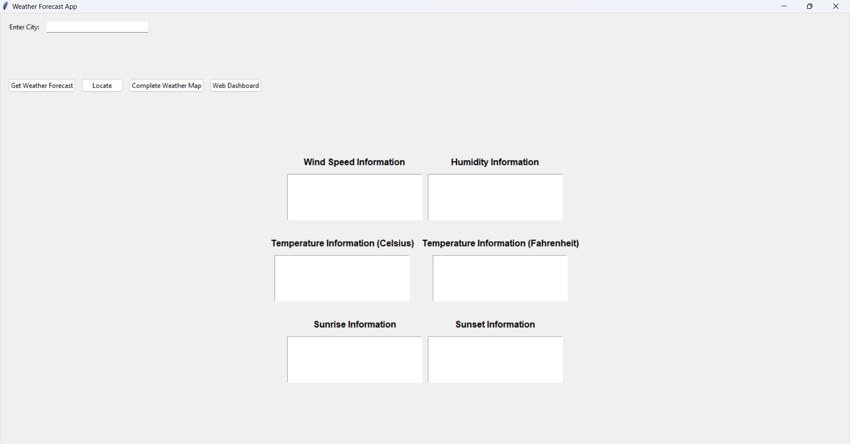

6

5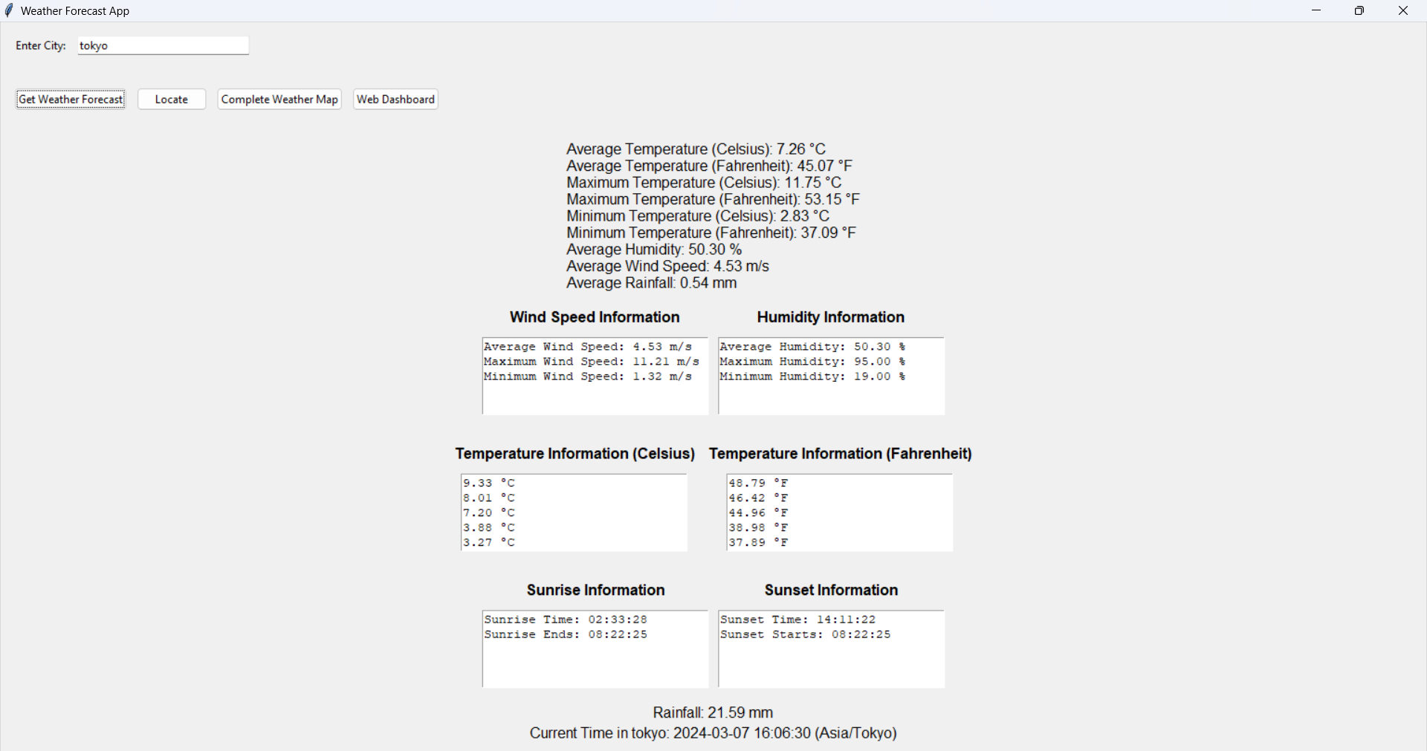

4

3

2

1

**Components of the App**

1. **City Input Field:** A text box where you can enter the name of a city to retrieve weather information for that location.
2. **Get Weather Forecast Button:** A button that initiates the process of fetching weather data from an external source (likely an API) based on the city name you entered.
3. **Locate :** Displays the Current Location of the input place
4. **Complete Weather Map:** This will redirect to the Open Weather map of Locations
5. **Web Dashboard:** This component is intended for the web version of this app developed using the no-code development strategies with a merge of Google API
6. **Weather Statistics Labels:** These labels display various weather statistics and details once you’ve retrieved the forecast for a city.

**Guide to use the application**

**1. Launching the Application:**

* Double-click the icon or executable file associated with the weather forecast application on your computer. This will launch the main window.

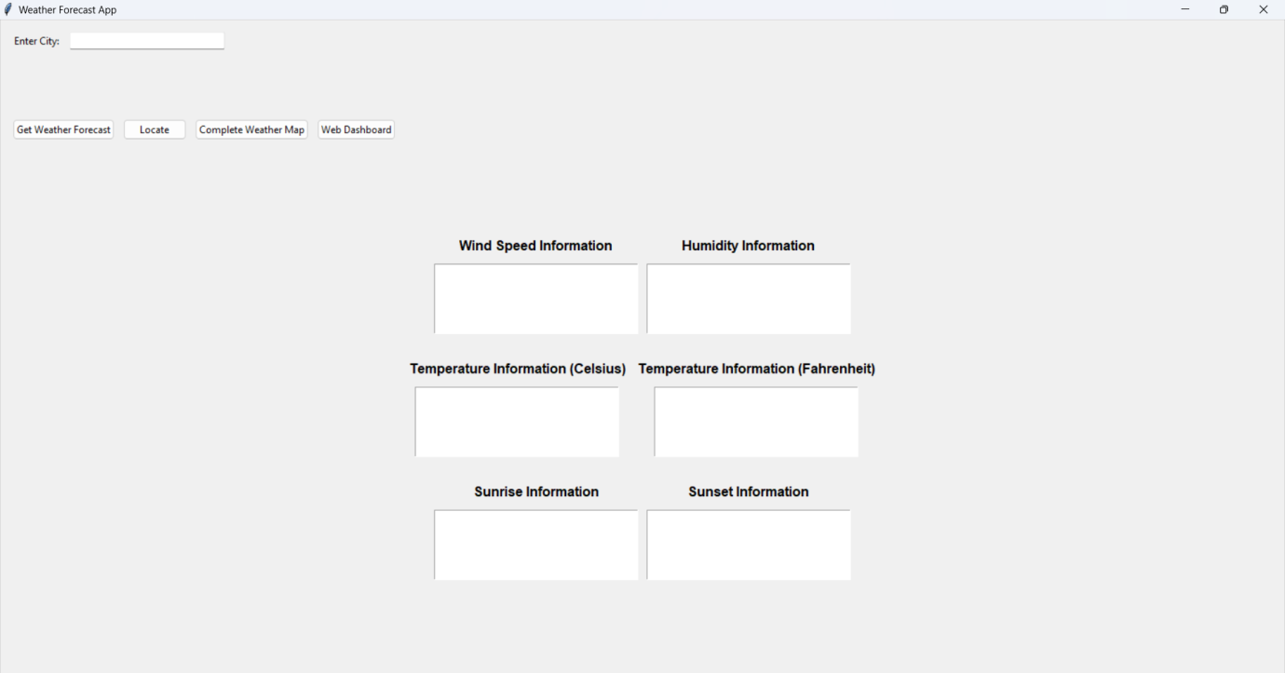

**2. Entering City Name:**

* Locate the input field in the window, which is likely labeled "City Name" or similar.
* Click inside the input field to activate it.
* Type the name of the city for which you want to retrieve weather information.
* **Example:** If you want to see the weather in London, you would type "London" in the input field.



**3. Retrieving Weather Forecast:**

* Locate the button labeled "Get Weather Forecast" or similar. This button typically triggers the process of fetching data from the weather API.
* Click the "Get Weather Forecast" button. The application will initiate the process of retrieving weather data for the city you entered.

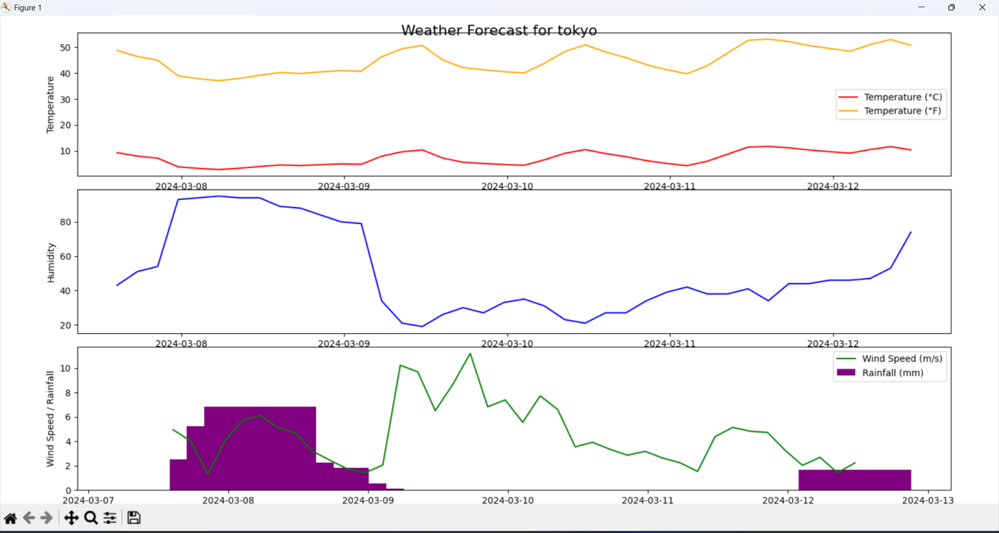

**4. Viewing Weather Information:**



* Depending on the application's design, you see a brief loading indicator or message while the data is being fetched.
* Once the data retrieval is complete, the application will populate various sections of the window with the weather information for the entered city. This information might be displayed in separate labels, text boxes, or other visual elements.
  + Typical weather information displayed might include:
    - **Temperature:** Current temperature, average temperature, minimum and maximum temperatures (often shown in both Celsius and Fahrenheit).
    - **Humidity:** Average or current humidity percentage.
    - **Wind Speed:** Average or current wind speed and direction.
    - **Sunrise/Sunset Times:** Exact times for sunrise and sunset, potentially including twilight periods.
    - **Rainfall (if available):** Total rainfall amount for the forecast period.
    - **Current Time in the City:** Time displayed based on the retrieved weather data and the city's time zone.

**5. Exploring Additional Features (Optional):**

* + **Display Heat Map Button:** If the application allows heat map visualization, this button would trigger a heat map creation process for the entered city. The provided code offers limited heat map functionality, so results might not be extensive.

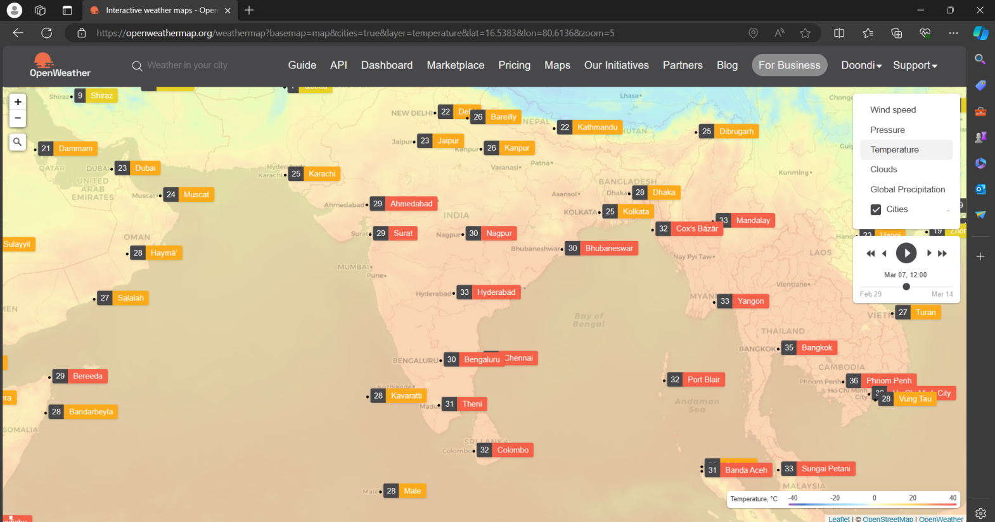

* + **Open Website Button:** Some applications include a button that opens a relevant
  + website in your web browser, such as a website dedicated to urban heat maps (the code you provided included functionality to open a specific website).

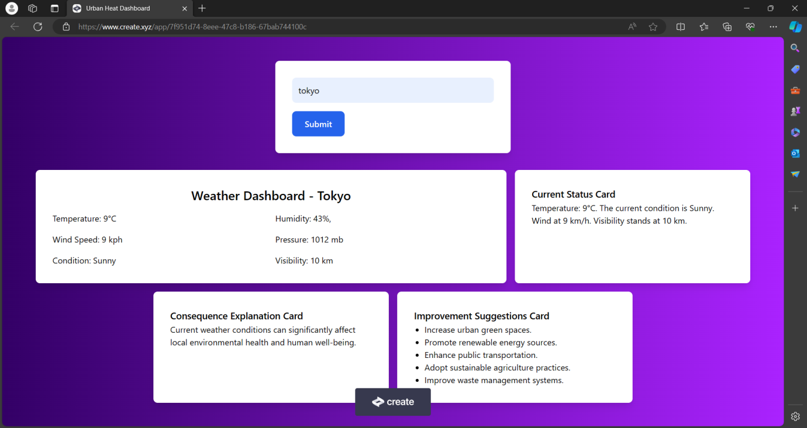

**Remember:**

* Ensure you have an internet connection for the application to function properly.
* The specific layout and elements of the GUI window might vary slightly depending on the application you're using.
* While the provided code offers heat map functionality, it's currently limited. Explore the application itself to see what heat map options are available.